# CINF 3331: Business Data Communications

# Assignment 3: LAN Configuration

# NAME:

Type your name in the space above. Save this file with a filename in this format – *First Name_Last Name_Assignment 3*.docx. **Don’t paste screenshot for this assignment. You need to upload your packet tracer file along with this Word file.** Name your packet tracer file using the same name as your word file.

You will need the following software installed on your PC to complete this homework assignment.

1. Packet Tracer.

# LAN Configuration (20 points)

Target: Create a local area network (LAN) that contains both wired and wireless connections as the figure below shows. And make sure all connections are valid.

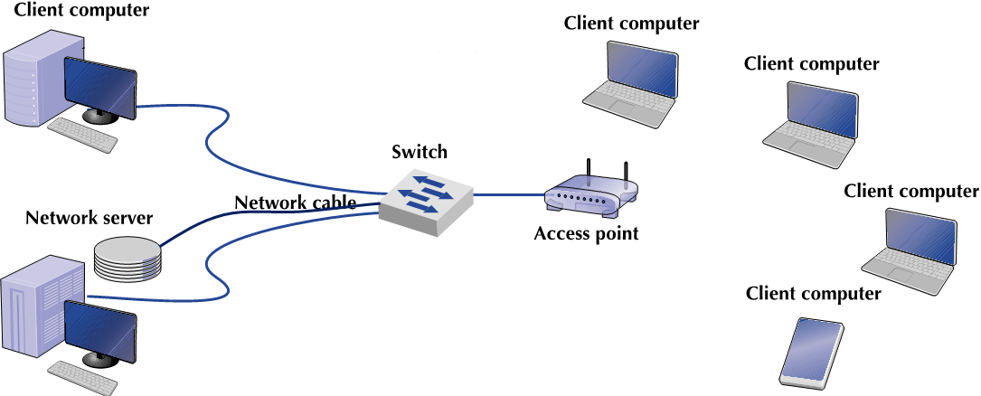

**Smartphone**

1. Add all devices:
   1. Choose “2960” as the switch you use.
   2. Choose “AP-PT” as the access point.
   3. Connect the wired devices use “Copper Straight-Through”.
2. Set your server to be a web server and a DHCP server. **(8 points)**
   1. Set the server’s name to “*Your Name’s* web and DHCP server”.
   2. Set the static IP address of this server to be 192.168.1.120. Use subnet mask 255.255.255.128. Set
      1. Default Gateway: 192.168.1.1
      2. DNS server: 192.168.1.2
   3. Turn the DHCP service on. Use the following setting as the DHCP server:
      1. Use above default gateway and DNS server information
      2. Start IP address: 192.168.1.0
      3. Subnet Mask: 255.255.255.128

What is the maximum number of users? Why? Remember toconfigure the number in DHCP setting. --- There are 7 remaining bits that are not masked. The number of users is 2^7 = 128, then -1 because the value 0 is usually reserved for special use.

* 1. Change the layout of the web homepage to
     1. Center text: CINF 3331: Business Data Communications
     2. Color of center text: orange
     3. Header: Welcome to *Your Name*’s Homepage
     4. Modify the “A small page” link to “My Introduction”. Edit the text on the linked page to be a brief introduction of yourself.
     5. Delete “Copyrights” link and the “Image” link.
     6. Modify the “Image page” link to “My Hobby”, on the linked page, show a picture of your hobby, e.g., show a book if your hobby is reading. Choose a picture of small size, less than 100kb.

1. Make sure all of your end devices’ (beside the server) IP addresses are configured through DHCP.

If we add an additional PC to the network and manually configure its IP address to 192.168.1.140, will it be able to communicate with the other PCs in the network? Why? **(3 points) The IP address 192.168.1.140 is not valid due to our subnet mask of 225.255.255.128. IP address range due to subnet mask is 192.168.1.0 – 192.168.1.127**

1. Open the setting interface of your access point. **(2 points)**
2. Go to Config tab, name the access point as you want.
3. Configure the name of your wireless signal to be CINF 3331.
4. Configure the authentication setting appropriately. Use *your student ID* as the connection password. Append any capital letter to the end if necessary.
5. Connect all laptops to the access point. Remember to change the physical network interface. **(2 points)**
6. Connect the smartphone to the access point. **(2 points)**
7. Use ping command or simple PDU to test all connections to make sure they are all valid. All end devices should be able to visit the website on the server. **(3 points)**